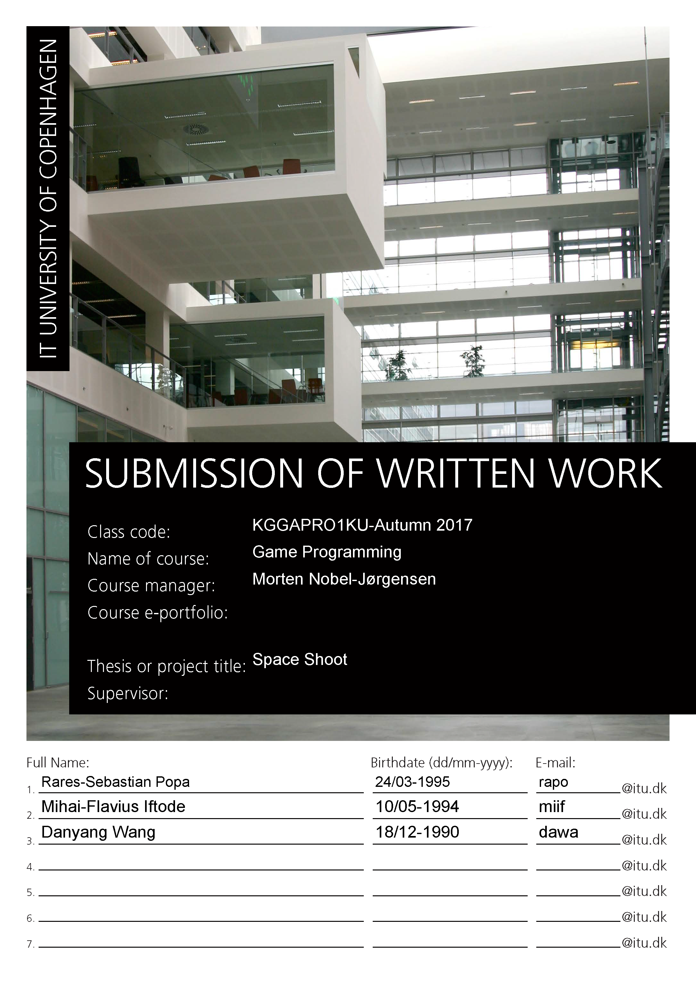

Space Shooter

Contents
Introduction 2
Implementation 2
Architecture overview 3
Physics integration 6
Resource management 6
Features implemented 6
Mihai Iftode 6
Danyang Wang 8
Rares Popa 9
Results and future improvements 9
The results 9
Future improvements 10
References 12

Introduction
The game we decided to build has the working title “Space Shoot” (short of Space Shooter). The main idea of the game is that you are tasked with clearing out an area of enemy turrets. There is no assurance that you will come out alive though, as the enemies outnumber you greatly. You are given a cruiser with a number of turrets. You must use the speed, firepower and your wits in order to kill as many enemies as possible. You must also keep a close eye on your ships’ internal systems in order to be as effective as possible.
As it is a project group, most of the project implementation was not done by a single person, even though one of us implemented a feature or added something to the codebase, that exact feature might have been refactored or redone completely to better suit our needs by another team member.
Controls are:
- W/S – ship thrust forward/backward
- A/D – ship rotation left/right
- Z – zoom mode for the camera
- X – debug draw
- Mouse/left mouse button – aim/shoot
The project was built using Simple Render Engine [1].

Implementation
The game contains the following features that are currently implemented:
- Space ship component
- Turret system
- Basic space ship subsystems
- Mouse and keyboard interaction
- Debug information
- Basic enemies
- Box2D [3] integration
One of the main features of the game is the Box2D integration. That means most of the interactions in game are done based on physical interactions between each element in the game.

Architecture overview
One of the problems we encountered is that we needed an architecture that allowed each element that was implemented to be loosely coupled. So we opted for a component based architecture [2].

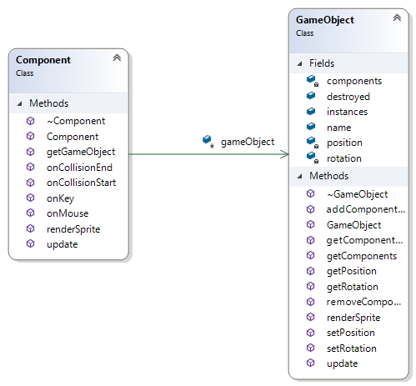
Figure 1 - Component and GameObject interaction.

The architecture we used is based on a course exercise because it suited our needs. In figure 1 we can see the base implementation of the GameObject hierarchy. In our project a GameObject is base object for all in-game objects, be it a space ship, a projectile, etc.
We decided to decorate each gameobject with components, so that it can implement and extend multiple functionalities hassle free. The gameobject class contains ways of adding and interacting with each of the components, so that it can safely add and remove components without leaking memory or having a general performance impact.

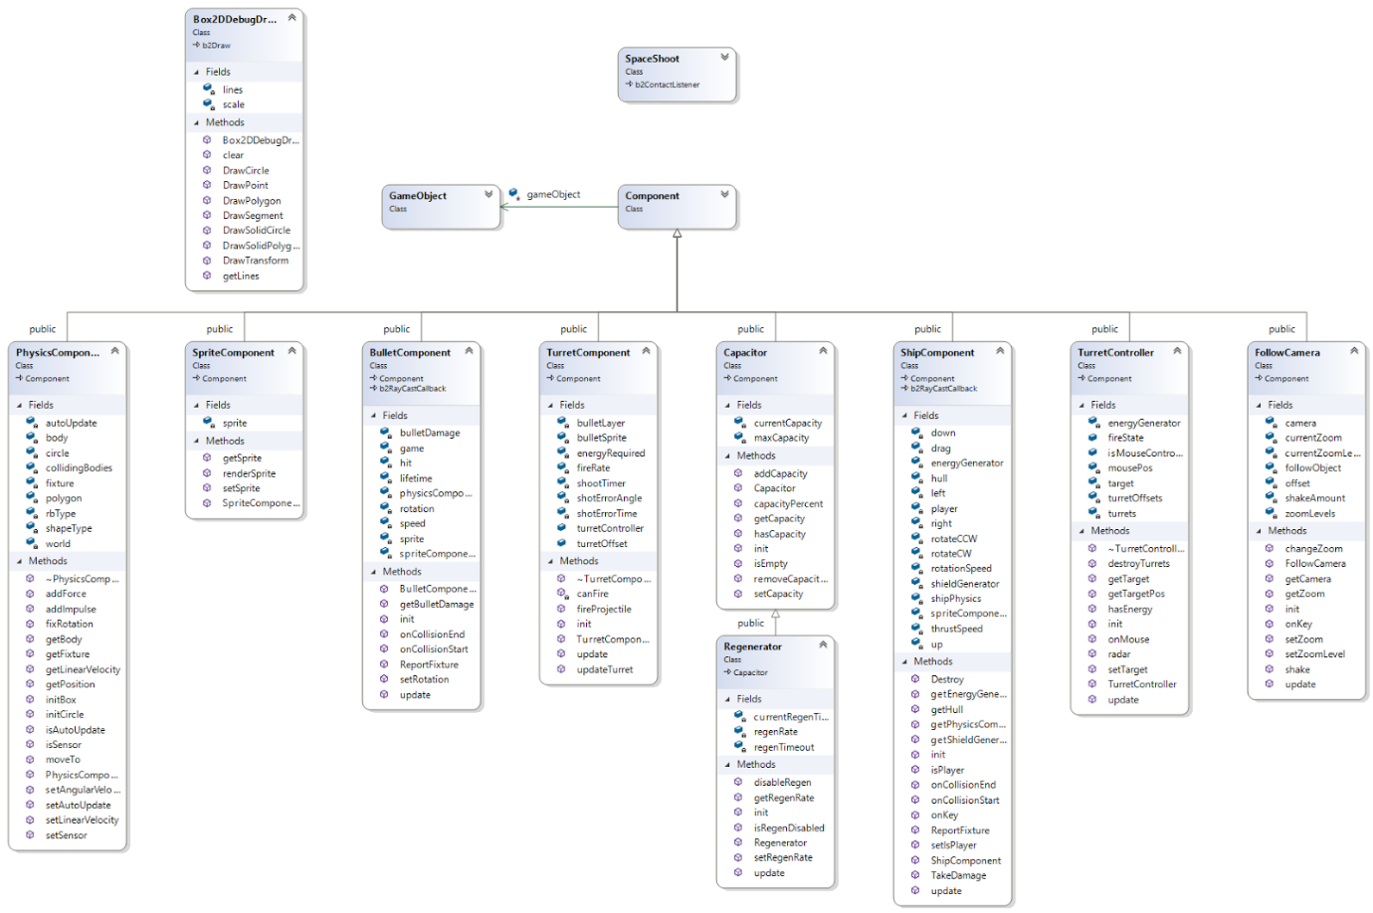
Figure 2 - detailed diagram of the project structure.
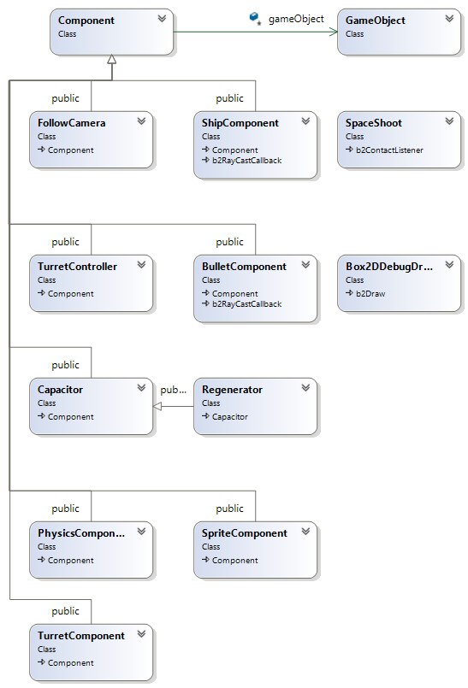
Figure 3 - Semi detailed diagram of the project structure.
Because of the decision to use a component based architecture, it made it easy to add and extend new features to the project. As seen in figure 2, and figure 3, the architecture can be seen in the way each new class is extended from the Component class.

Physics integration
To allow real world physical interaction, we decided to integrate Box2D as a component inside the game. With it we can do things like velocities, collision detection, apply forces to a certain object, etc.

Resource management
Because of the fact that the game is mostly 2D, we used the simple render engine sprite management capabilities, called SpriteAtlas, with which we load the sprites that we need from the sprite sheet. As such we can easily reuse the same sprite without the need to reread it form the disk.

Features implemented

Mihai Iftode
In the next section I will explain what I managed to implement and explain my reasoning for it and detail further improvements that could have been done. I will also present in detail some of the features that I find interesting that were hard to get right.
I worked and implemented the following parts:
- Initial project setup and architecture type setup (component-based)
- Added the initial follow camera script
- Added ship movement and rotation inside the ship component using box2d
- Delete “destroyed” objects from global object list
- Added turrets that follow the mouse pointer
- Added bullets/projectiles that are shot from each turret with a custom trajectory(mouse or target)
Most of the features that I implemented were built upon or refactored to better suit other features, for example the turret component and controller were heavily modified so that they can support the energy and health system.

Box2D Integration
The box2d component wraps around the box2d classes, the only issue is that all of the interactions like setting the position and the rotation must be done through box2d and in different situations it posed a problem.
One issue found was that of the collisions between the player bullet and the player collision box, I fix this issue by using layers, so that the player and the bullet it fired do not collide with one another.
Another issue is regarding collision detection, if a bullet hit something I want to remove it from memory, the problem came up with the way box2d worked and that it expects that once something came in contact with an object, it must also leave that contact. In some cases it would remain in contact, and by deleting it while it was still in contact it would automatically call the endContact() method and it would find an empty pointer. The answer was that while deleting an object, collision detection should be stopped.

Ship movement
The ship must move forward and backwards, but it also must support rotation, the problem was calculating the correct direction when the ship was moving forward and rotating. All of this is done through box2D by applying different forces or by setting the ships velocity at each step.

Destroying objects
To be able to correctly remove an object, one must set its property destroyed to true, and the object will be removed in the next update step. One of the issues was explained in the box2d integration. Also destroying objects that have dependencies on other objects might introduce bugs that break the game. Such as, destroying an enemy ship will not be correctly done if its turret component are not destroyed correctly.
Currently, before we destroy a game object, we iterate through the entire list of game objects. This can introduce performance issues if too many gameobjects are present.

Turrets
Each turret is able to either follow the mouse or another target, depending if it’s a player or not.
One issue that came up is that in order to correctly translate the mouse coordinates, we must also take in account the mouse position related to the in-game position.

Projectiles
In order to make projectiles work, they need to use a physics component. With that we have collision detection, and we can tell what object it hits. In order to fire a projectile, we give it a trajectory and when it hits the target, the projectile is destroyed.
One issue that came up is that if we have a great number of gameobjects, especially those that require Box2D physics, the performance of the game will decrease.

Danyang Wang
Was tasked to finish a particle system, unfortunately didn’t manage to complete it. I try to use Particle system for spaceship engine fire.
Add simple data object in Particle class:
//Physics part
Glm::vec3 position(x,y,z);
Glm::vec3 Velocity ;
We do not consider the gravity. Therefore velocity is not based on constant acceleration.
//lifetime
Bool active;
Float life;
Float fade;//using this to make fade out rate.
//appearance
float size;
Glm::vec4 colour;
Glm::vec4 uv.

Then implementation of the particleSystem class.

Adding particles numbers.
In draw function, setting texture and rendering.
In emit function, setting the continuous number of particles emitted values, like time of instantiation, particles' lifetime. Using control key as the trigger. Particles will slowly disappear with time. And Particles beginning position will always follow with engines at the trail of spaceship.
In update function, updating the color,uv,size and position based on deltatime.
There is a problem that I want to make particles direction always behind the direction of spaceship engines. But it does not work well.

Rares Popa
My tasks within this project include:
- Writing (from this sub-chapter onwards), proof reading (until this sub-chapter) and generating the report
- Identifying the components that need to be implemented and distributing tasks
- Optimizing and refactoring code
- Balancing of gameplay and adding polish
- UI, Game State, Assets
- Camera zoom and shake
- Ship subsystems
The Capacitor and Regenerator class are used to create the functionality of the hull, shield and energy generators. The Capacitor class holds a quantity, and has a number of useful tools to manipulate that quantity to simulate all the required use cases. The Regenerator class inherits from Capacitor, and adds the option to regenerate the quantity by a rate, to disable the regeneration by a certain amount of time etc.
The TurretController and TurretController went through 3 and 2 major changes. The TurretController was first implemented mostly by Mihai, it had the basic functionality of a multiple-turret system. In the second generation, we improved upon that system by splitting the TurretController into a class that manages multiple gameobjects with TurretComponents attached to them. In the third major change, I refactored both classes in order to make them more general, add the need for energy and an energy generator and further improving on the way the turret fires. A basic radar function for enemies was added also.

Results and future improvements

The results
We managed to implement an array of basic ship subsystems and managing tools, which can be easily modified to suit any needs. The systems are also easily modifiable and can be expanded to add more complexity.
In order to correctly assess the contribution of each member, consider checking the commits on github. Most of the functions are commented in the header file, if their role is not obvious enough.

Future improvements
There are a number of subsystems that we weren’t able to implement in time for the deadline. In order of importance are listed below.

Enemy information
Currently there is no way on telling the hull and shields of the enemy. UI elements that display such information, either in a window that shows stats about the currently hovered/targeted entity or displaying information on each enemy on the screen.

Radar subsystem
An easy and straight-forward implementation would be to have a sensor trigger collider that will keep track of relevant gameobjects. It would then be used by the turrets and other space ship systems in order to act in a more realistic matter.

Minimap
Using the radar subsystem, a minimap can be drawn. We do this by taking all the objects detected by the radar sub-system and normalizing their positions by a certain factor, in order to display them on a UI element.

Other turret enhancements
Calculating the target lead correctly. We do this by adding the targets’ velocity delta, and scaling it by the number of seconds it would take for the projectile to hit it, assuming the target’s course doesn’t change.
Different projectile types (lasers, missiles etc.). Ammunition.
Clamped rotation vs. full 360 degree rotation. If implemented, would allow for other gun types rather than 360 degree turrets. We would then set the initial rotation and a certain angle to stay within, using that initial rotation. All this in respect to the parent’s rotation.
Rotation over time vs. instant rotation. We would basically calculate the angle we need to rotate to and use a function that would rotate the turret towards it at a constant rate or even lerp/slerp. We would, of course, need to have a field for the maxRotationSpeed of it and use that.
Calculating the angular velocity for the nearby targets and choosing the optimal target to fire upon. This is a very niche feature, as it will only have benefits if there are multiple ship types. If there would be, let’s say a fighter class ship that is moving very fast, and a battleship class ship that would have very slow turning turrets, we wouldn’t want to waste time trying to fire upon the fighter if there are slower targets nearby.

Space Ship A.I.
Taking place in space and being in a 2D setting, an enemy A.I. shouldn’t be difficult to implement. The ShipController class would need to be split into more general functions that can be used by an A.I. component. The pathfinding should be straightforward, with a few simple raycasts it should be more than enough to make a good enough A.I. for the project’s purpose.
Flocking algorithm to be used by fighter wings.
Adaptive target switching depending on the ship type.
Faction system.

Factory methods and class [4]
Keeping track of the initialization for different object types is tedious. An optimal solution would be having .json [5] files with configurations for initializing within a factory class. The creation and configuration of objects would be greatly improved.

Others
Implementation of sounds, more music.
Ingame economy, mining, bases, trading, ship subsystem types, ability to modify the configuration of the space ship and the space ship itself.
Multiple systems.
Data persistence.
Missions.

References

[1] Simple Render Engine: https://github.com/mortennobel/SimpleRenderEngineProject
[2] Component based architecture: http://gameprogrammingpatterns.com/component.html
[3] Box2D: http://box2d.org/
[4] Factory method pattern: https://en.wikipedia.org/wiki/Factory_method_pattern
[5] JSON: https://www.json.org/

